课程编号：100072107 北京理工大学 2021 – 2022学年第二学期（页面中所有文字不要删除）
2022年《面向对象技术与方法》试卷
班级： 学号： 姓名： 卷面成绩：

注意：一共有三道编程题，同学们根据本课程《考试须知》中的要求，在规定的截止时间之前把此答卷发到授课老师的电子邮箱。对每一道编程题目，都要写出自己的源代码（注释可用中文）、以及运行结果的截屏。

考试诚信承诺书
我承诺已成功下载本次考试试卷，并自己完成答题，诚信考试
此处贴上你的签名： ________________

1 (35 points)完成类Calculator的设计.
#include <iostream>  using namespace std;  class Calculator  {  private: int value;  public: // your functions:  ……  };  int main()  {  Calculator m(5), n;  m = m + n;  return 0;  } | The outputs:  Constructor value = 5  Constructor value = 3  Constructor value = 8  Assignment value = 8  Destructor value =8  Destructor value = 3  Destructor value = 8

//【你的带注释的源代码】
#include <iostream>
#include <cstdio>
using namespace std;
class Calculator
{
private: int value;
public: // your functions:
Calculator(int num) {//带参数的构造函数
this->value = num;
printf("Constructor value = %d\n", this->value);
}
Calculator() {//不带参数的构造函数
this->value = 3;
printf("Constructor value = %d\n", this->value);
}
Calculator operator+(const Calculator& t) {//重载加号

int num = this->value + t.value;
Calculator c(num);
return c;
}
void operator=(const Calculator& t) {//重载等号
//Calculator c;
//c.value=t.value;
this->value = t.value;
printf("Assignment value = %d\n", this->value);
//return c;
}
~Calculator() {//析构函数
printf("Destructor value = %d\n", this->value);
}
};
int main()
{
Calculator m(5), n;
m = m + n;
return 0;
}

//【运行结果的截屏】
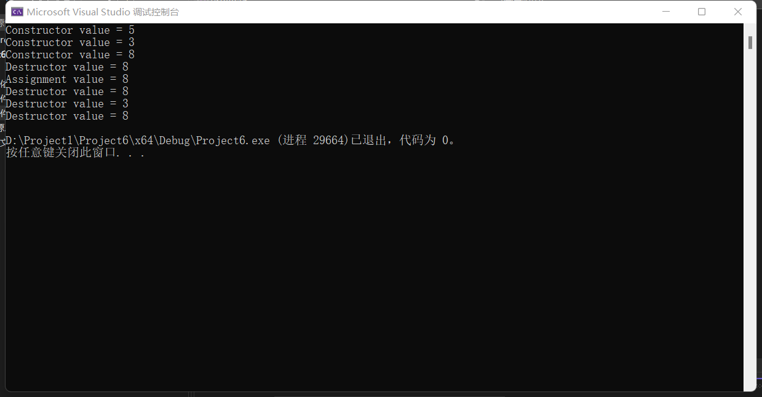

2 (30 points) 完成类Animal、Wolf、Tiger的设计.
#include <iostream>  #include <string>  using namespace std;  class Food  {  string FoodName;  public:  Food(string s) : FoodName(s) { };  string GetFoodName() { return FoodName; }  };  class Animal // abstract class  {  string AnimalName;  Food& food;  public: // your functions:  ……  };  class Wolf : public Animal  {  public: // your functions:  ……  }; | class Tiger : public Animal  {  public: // your functions:  ……  };  int main()  {  Food meat("meat");  Animal* panimal = new Wolf("wolf", meat);  panimal->Eat(); // display: Wolf::Eat  cout << *panimal << endl; // display: Wolf likes to eat meat.  delete panimal;  panimal = new Tiger("Tiger", meat);  panimal->Eat(); // display: Tiger::Eat  cout << *panimal << endl; // display: Tiger likes to eat meat.  delete panimal;  return 0;  }

//【你的带注释的源代码】
#include<iostream>
#include<string>
using namespace std;
class Food
{
string FoodName;
public:
Food(string s) :FoodName(s) {};
string getFoodName() { return FoodName; }
};
class Animal //抽象类
{
string AnimalName;
Food& food;
public:
virtual void Eat() = 0;//纯虚函数
const string& GetAnimalName()const { return AnimalName; }//返回名称
Animal(string s, Food& f) :AnimalName(s), food(f) {};//构造函数
Food& getFood() const
{
return food;
}
//返回食物//返回食物
};
class Wolf :public Animal
{
public:

}
class Tiger :public Animal
{
public:

};
int main()
{
Food meat("meat");
Animal* panimal = new Wolf("wolf", meat);
panimal->Eat(); // display: Wolf::Eat
cout << *panimal << endl; // display: Wolf likes to eat meat.
delete panimal;
panimal = new Tiger("Tiger", meat);
panimal->Eat(); // display: Tiger::Eat
cout << *panimal << endl; // display: Tiger likes to eat meat.
delete panimal;
return 0;
}

//【运行结果的截屏】
未完成全部

3 (35 points) 设计一个数组类模板MArray (注意不允许基于标准库中的类模板产生MArray)，使用户可以在如下main函数中应用并显示相应的结果.
#include <iostream>  # include <string>  using namespace std;  // Your definition of MArray:  …… | int main()  {  MArray<int> intArray(5); // 5 is the number of elements  for (int i = 0; i<5; i++)  intArray[i] = i * i;  MArray<string> stringArray(2);  stringArray [0] = "string0";  stringArray [1] = "string1";  MArray<string> stringArray1 = stringArray;  cout << intArray << endl; // display: 0, 1, 4, 9, 16,  cout << stringArray1 << endl; // display: string0, string1,  return 0;  }

//【你的带注释的源代码】
#include <iostream>
# include <string>
using namespace std;

template<typename T>
class MArray {
public:
MArray(int Size) { //类的构造函数
this->Size=Size;
Array=new T[Size];
}
T& operator [](int sub) { //重载下标运算符
return Array[sub];
}
~MArray() { //类的析构函数
delete []this->Array;
}
friend ostream &operator<<(ostream &ost,MArray &a) { //重载输出流运算符
ost<<a.Array[0];
for(int i=1; i<a.Size; i++) {
ost<<','<<a.Array[i];
}
return ost;
}
private:
int Size;//数组的大小
T *Array;
};

int main() {
MArray<int> intArray(5); // 5 is the number of elements
for (int i = 0; i<5; i++)
intArray[i] = i * i;
MArray<string> stringArray(2);
stringArray [0] = "string0";
stringArray [1] = "string1";
MArray<string> stringArray1 = stringArray;
cout << intArray << endl; // display: 0, 1, 4, 9, 16,
cout << stringArray1 << endl; // display: string0, string1,
return 0;
}//【运行结果的截屏】
